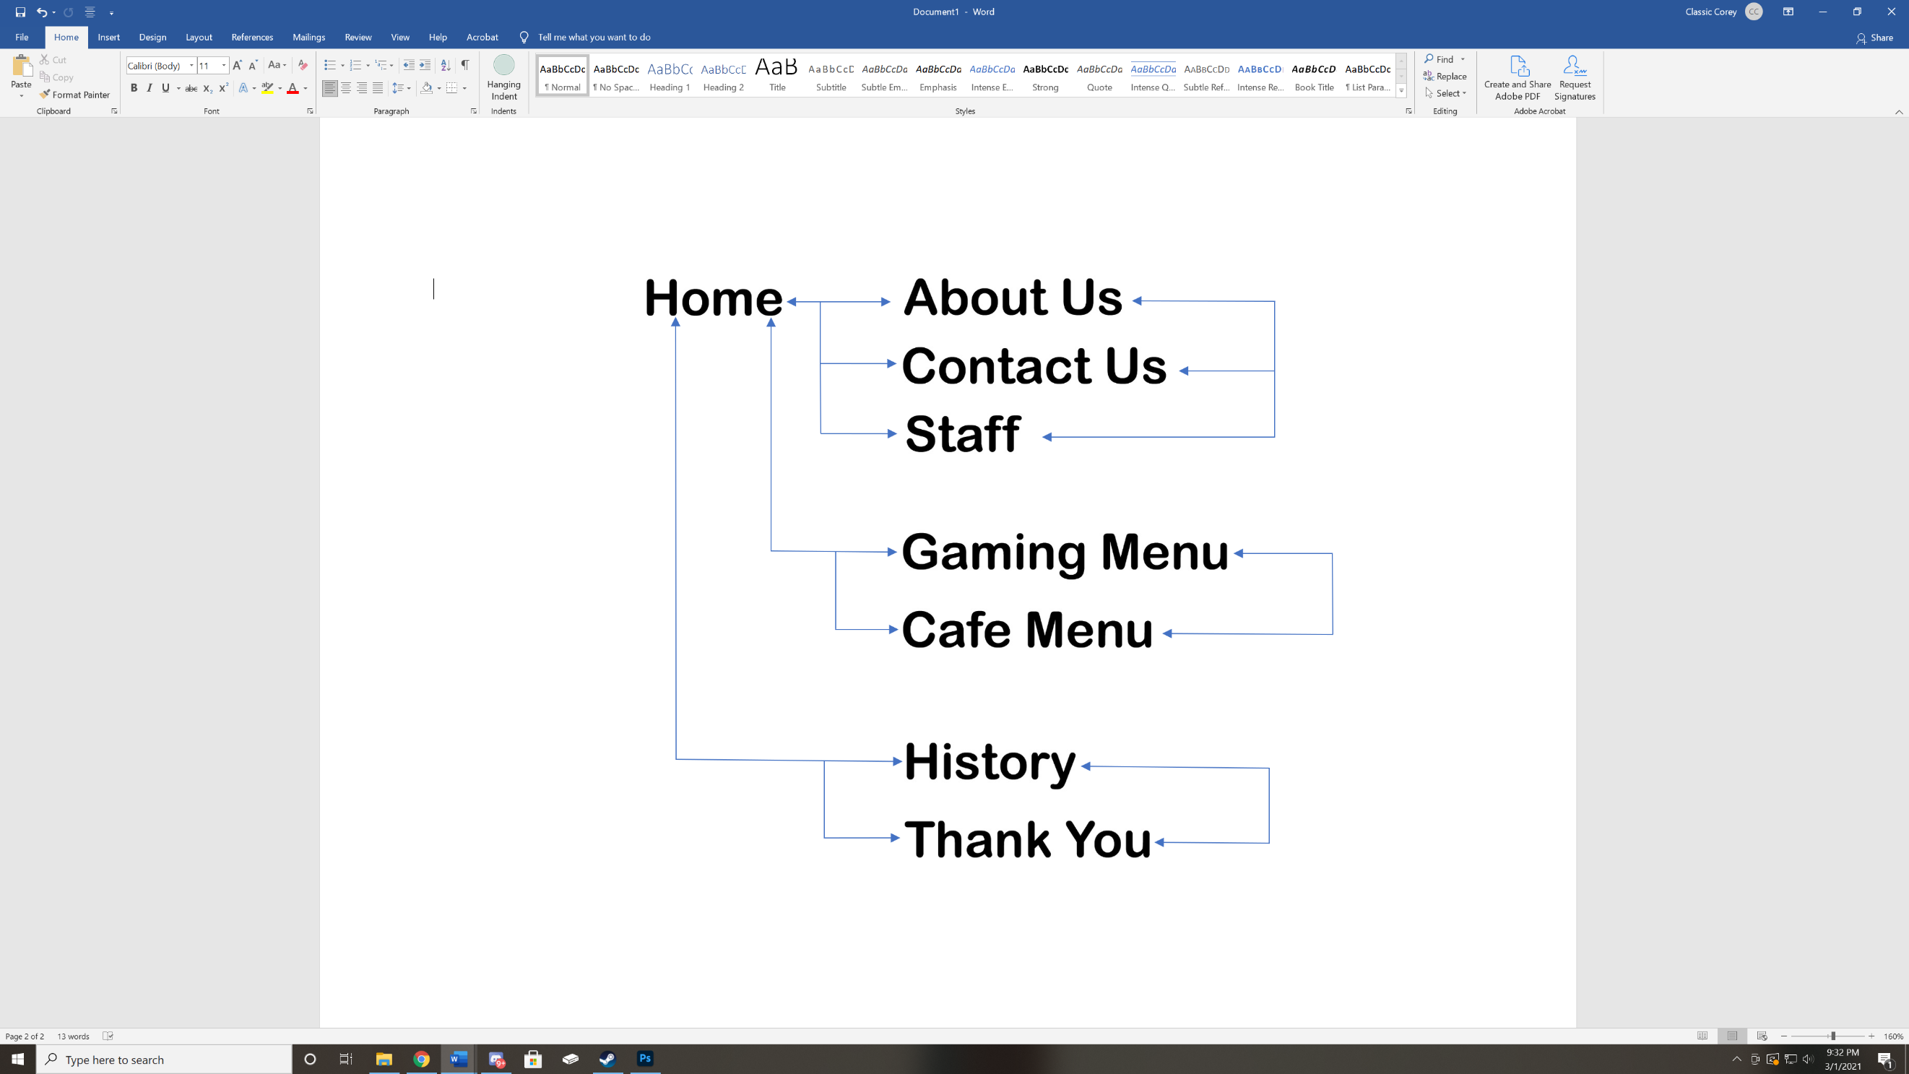
Graphics
Universal Style Sheet (CSS)

